
Corporation of the City of Kawartha Lakes
Procurement Division
P.O. Box 9000, 26 Francis Street,
Lindsay, ON, K9V 5R8
Tel: 705-324-9411
Toll free at 1-888-822-2225

Addendum #5
2026-034-CQ - Renovations to the Fenelon Falls Fire Hall
Closing Date: Thursday, April 23, 2026 11:00 AM

This addendum forms part of the procurement document and is to be read, interpreted and coordinated with all other parts. The following information supersedes the information contained in the original procurement document.

Questions and Answers

Question 1:
The specified gas monitor panel is discontinued and no longer available. Is there an alternate model recommended by the engineer as a substitute?

Answer 1:
Looks like since the time we created the drawings the Armstrong panel was discontinued. I’ve attached an alternate, looks like it’s just the next generation model. Panel AMC-1A.. becomes AMC-1B.. I’ve also highlighted on page two a compatible sensor. The specs for the panel and sensor are on the schedule on the drawings too, and contractors are free to price alternates that meet these requirements (subject to shop drawing review)

Question 2:
In Electrical drawing E1, detail 2 - single line diagram. It shows the new 60amp panel being supplied by an existing 60amp panel, is this accurate?

Answer 2:
Single line should be as follows shown with 200A panel supplying new 60A panel ‘B’
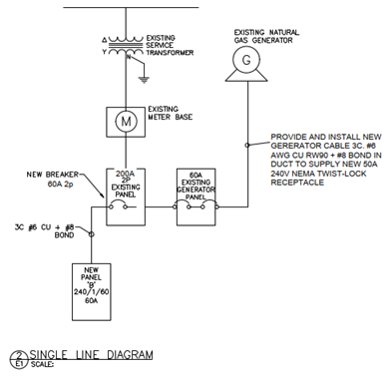

Question 3:
Could you please confirm and provide the make, model, and BTU specifications of the existing ceiling-mounted gas heater?

Answer 3:
Please see the attached photos of the name plate of the existing ceiling-mounted gas heater.
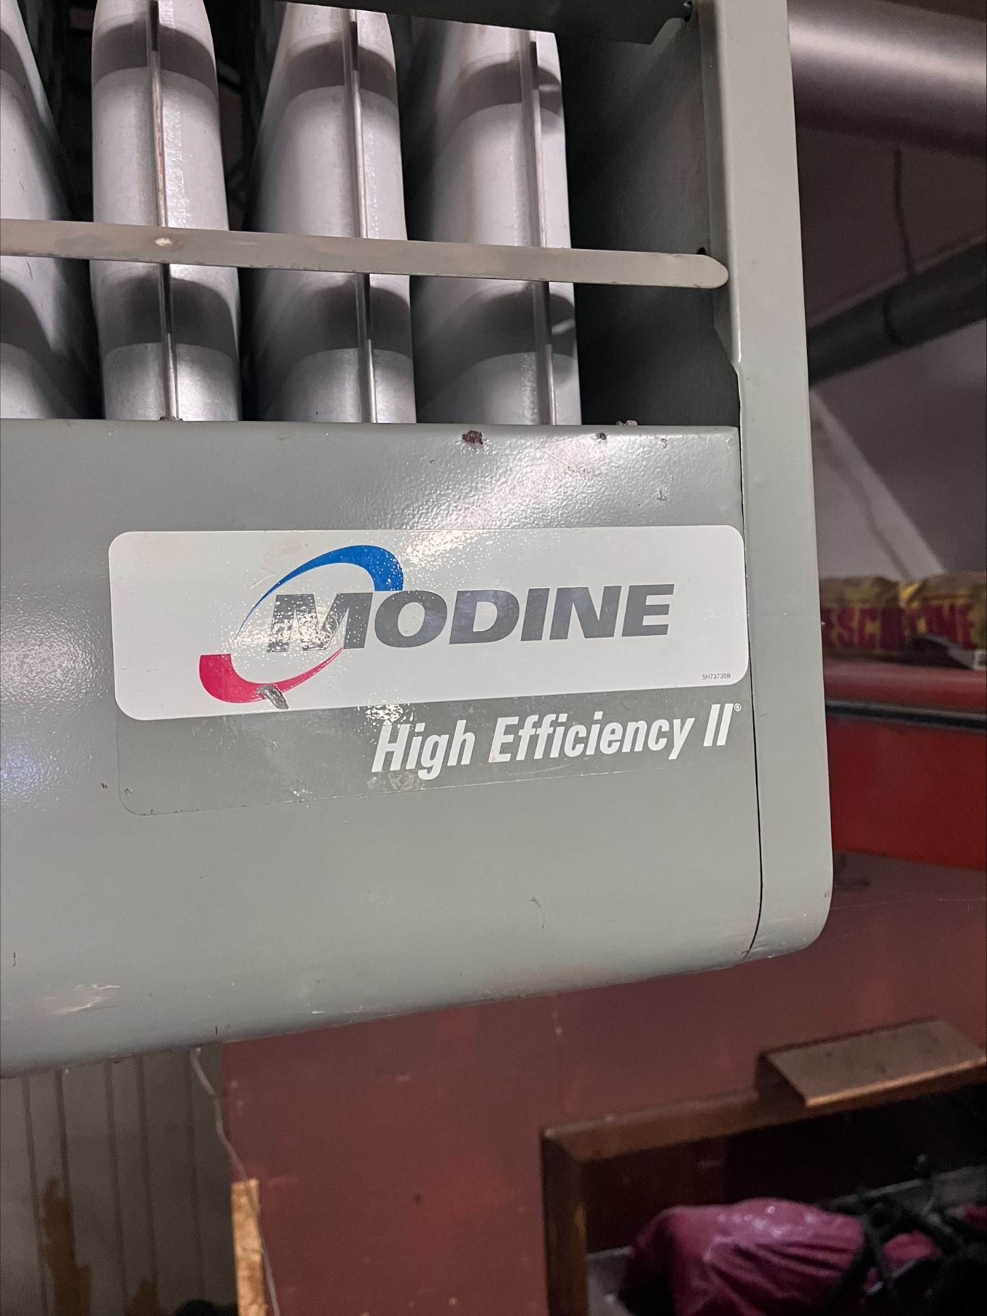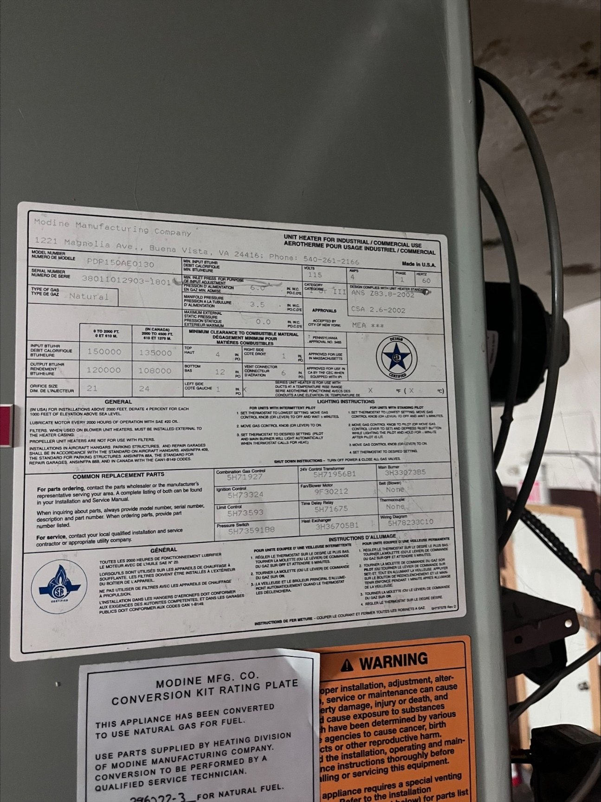

Question 4:
Electrical - Distribution Clarifications:
Distribution says existing, however the note on drawing says to demo meter base and panel.
Please confirm the location of the new meter base.
Please Confirm the Size of Service & Panel that are to be removed
Please Confirm the Size of the Generator Wire and Rec that needs to be re-run

Answer 4:
Clarification: at present there are 2 separate meters and 2 services on site, 1 for the main fire station building and 1 for the storage building to the north that will be demolished.
The Storage building service will be removed as noted on the Drawings Note 1
All power for the new storage building will come from the existing main fire station panel as per the SLD (revised above)
Existing service that is to be removed in the storage building has a 200A meter that supplies a 100A disconnect, a panel and a sub panel. Electrician should review the site for demolition requirements.
See single line for generator wire rerun details

Question 5:
Could you please clarify the wall finish at the new Gear Storage Room? The drawing A6 indicates a 12.7 mm composite waterproof finish, while the finish schedule in the specifications indicates DW/PT. Please confirm whether there is a corresponding specification section for the composite waterproof finish.

Answer 5:
Delete painting of drywall walls as called for in the room finish schedule. Install FRP (fibre glass reinforced panels) for all walls as indicated on section 1/A6 for this room. Retain drywall / painted ceiling for this room as called for.

Question 6:
Could you please confirm the final finish of the new concrete slab?

Answer 6:
Clear sealer as per item 3.4 under section 03300 cast in place concrete.

Question 7:
1. Please clarify the area or scope of asphalt removal and replacement. Are we only repaving where it is disturbed?

Answer 7:
Yes.

Question 8:
2. There appears to be a strip of soil and vegetation along the north side of the existing building. Is that to be replaced with gravel, or pavement? Please specify.

Answer 8:
Pavement.

Attachments:

- 2026-034-CQ Addendum 5 3550422A-DOC-AMC-1B-Series-Marketing-Spec-1 - Attachment 1

If you have any questions, please submit them through Bids & Tenders.

End of Addendum #5

